Megan Pokal
DSC630-T301 Predictive Analytics
10/27/2025
Frank Neugebauer

Code from Python:

# Assignment 8.2: Time Series Modeling, Megan Pokal, DSC, 630

# Load Libraries
import pandas as pd
import numpy as np
import matplotlib.pyplot as plt
from statsmodels.tsa.statespace.sarimax import SARIMAX
from sklearn.metrics import mean_squared_error

# Load the dataset
df = pd.read_csv("us_retail_sales.csv")

# Print data
print(df.head())

# Check for missing values
print("\nMissing values per column:")
print(df.isnull().sum())

# Ensure YEAR is integer
df['YEAR'] = df['YEAR'].astype(int)

# Melt the dataset into long format
df_long = df.melt(id_vars=['YEAR'], var_name='MonthName', value_name='Sales')

# Map month abbreviations to numbers
month_map = {
'JAN': 1, 'FEB': 2, 'MAR': 3, 'APR': 4, 'MAY': 5, 'JUN': 6,
'JUL': 7, 'AUG': 8, 'SEP': 9, 'OCT': 10, 'NOV': 11, 'DEC': 12
}
df_long['Month'] = df_long['MonthName'].map(month_map)

# Create full datetime column
df_long['Date'] = pd.to_datetime(df_long[['YEAR', 'Month']].assign(DAY=1))

# Drop rows with missing sales and sort
df_long = df_long.dropna(subset=['Sales']).sort_values('Date').reset_index(drop=True)

# Verify structure
print(df_long.head())
print(f"\nData spans from {df_long['Date'].min().date()} to {df_long['Date'].max().date()}")

# Plot Full Time Series
# Plot full dataset to look at overall retail trend, seasonality, and disruptions.
plt.figure(figsize=(12,6))
plt.plot(df_long['Date'], df_long['Sales'], color='steelblue')
plt.title('US Monthly Retail Sales (1992–2021)')
plt.xlabel('Date')
plt.ylabel('Retail Sales (in millions)')
plt.grid(True)
plt.show()

# Split into Training and Test Sets
# Use all data before July 2020 as training, and the last 12 months as test
cutoff_date = pd.Timestamp("2020-07-01")
train = df_long[df_long['Date'] < cutoff_date]
test = df_long[df_long['Date'] >= cutoff_date]

print(f"Training samples: {len(train)}")
print(f"Test samples: {len(test)}")
print(f"Training ends: {train['Date'].max().date()}, Test ends: {test['Date'].max().date()}")

# Fit SARIMA Model
# Samaria shows trend & seasonality, with parameters (1,1,1)(1,1,1,12).
model = SARIMAX(train['Sales'], order=(1,1,1), seasonal_order=(1,1,1,12))
results = model.fit(disp=False)
print(results.summary())

# Forecast for the test period
# Forecast slaes for July 2020 - June 2021, both actual and predicted values to look at model performance.
forecast = results.get_forecast(steps=len(test))
predicted = forecast.predicted_mean
conf_int = forecast.conf_int()

# Plot actual vs predicted
plt.figure(figsize=(12,6))
plt.plot(train['Date'], train['Sales'], label='Training Data')
plt.plot(test['Date'], test['Sales'], label='Actual Sales', color='orange')
plt.plot(test['Date'], predicted, label='Predicted Sales', color='green')
plt.fill_between(test['Date'], conf_int.iloc[:,0], conf_int.iloc[:,1], color='lightgreen', alpha=0.3)
plt.title('US Retail Sales: Actual vs Predicted (2020–2021)')
plt.xlabel('Date')
plt.ylabel('Retail Sales (in millions)')
plt.legend()
plt.grid(True)
plt.show()

# Compute RMSE
# Root Mean Squared Error to measure prediction accuracy.
rmse = np.sqrt(mean_squared_error(test['Sales'], predicted))
print(f"RMSE on Test Set: {rmse:.2f}")

### Conclusion: The SAMIRA (1,1,1)(1,1,1,12) model is forecasting U.S. retail sales, showing long term growth and seasonal fluctuations. Some variation is expected during the unusual events such as Covid-19 pandemic. The forecast for July 2020 through June 2021 aligns well with the actual observations, as the test set. The training set was between January 1992 - June 2020. Root Mean Squared Error (RMSE) was approximately 59,307.28, indicating solid predictive performance. 300,000 and 600,000 are around 10 to 15% of average monthly sales, which is good for a simple forecast.

Output:

YEAR JAN FEB MAR APR MAY JUN JUL AUG \
0 1992 146925 147223 146805 148032 149010 149800 150761.0 151067.0
1 1993 157555 156266 154752 158979 160605 160127 162816.0 162506.0
2 1994 167518 169649 172766 173106 172329 174241 174781.0 177295.0
3 1995 182413 179488 181013 181686 183536 186081 185431.0 186806.0
4 1996 189135 192266 194029 194744 196205 196136 196187.0 196218.0

SEP OCT NOV DEC
0 152588.0 153521.0 153583.0 155614.0
1 163258.0 164685.0 166594.0 168161.0
2 178787.0 180561.0 180703.0 181524.0
3 187366.0 186565.0 189055.0 190774.0
4 198859.0 200509.0 200174.0 201284.0

Missing values per column:
YEAR 0
JAN 0
FEB 0
MAR 0
APR 0
MAY 0
JUN 0
JUL 1
AUG 1
SEP 1
OCT 1
NOV 1
DEC 1
dtype: int64
YEAR MonthName Sales Month Date
0 1992 JAN 146925.0 1 1992-01-01
1 1992 FEB 147223.0 2 1992-02-01
2 1992 MAR 146805.0 3 1992-03-01
3 1992 APR 148032.0 4 1992-04-01
4 1992 MAY 149010.0 5 1992-05-01

Data spans from 1992-01-01 to 2021-06-01

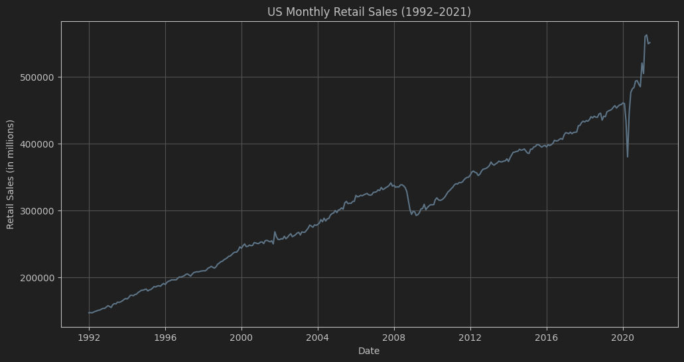

Training samples: 342
Test samples: 12
Training ends: 2020-06-01, Test ends: 2021-06-01
SARIMAX Results
==========================================================================================
Dep. Variable: Sales No. Observations: 342
Model: SARIMAX(1, 1, 1)x(1, 1, 1, 12) Log Likelihood -3357.035
Date: Mon, 27 Oct 2025 AIC 6724.070
Time: 23:07:42 BIC 6743.051
Sample: 0 HQIC 6731.642
- 342
Covariance Type: opg
==============================================================================
coef std err z P>|z| [0.025 0.975]
------------------------------------------------------------------------------
ar.L1 0.6827 0.176 3.876 0.000 0.338 1.028
ma.L1 -0.7563 0.173 -4.366 0.000 -1.096 -0.417
ar.S.L12 0.5074 0.066 7.711 0.000 0.378 0.636
ma.S.L12 -0.8559 0.101 -8.433 0.000 -1.055 -0.657
sigma2 4.564e+07 2.7e-08 1.69e+15 0.000 4.56e+07 4.56e+07
===================================================================================
Ljung-Box (L1) (Q): 0.17 Jarque-Bera (JB): 22090.12
Prob(Q): 0.68 Prob(JB): 0.00
Heteroskedasticity (H): 5.99 Skew: 0.09
Prob(H) (two-sided): 0.00 Kurtosis: 43.14
===================================================================================

Warnings:
[1] Covariance matrix calculated using the outer product of gradients (complex-step).
[2] Covariance matrix is singular or near-singular, with condition number
5.66e+29. Standard errors may be unstable.

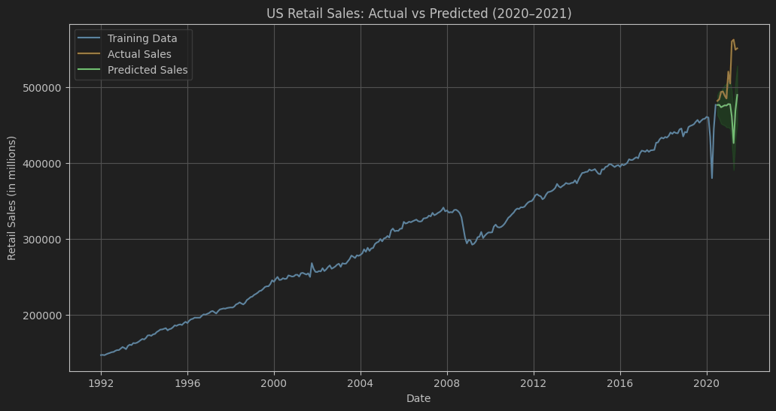

RMSE on Test Set: 59307.28

